**S**tate **T**ransition and **P**airwise **T**esting

# ST

## Exercise 1 – Credit Card on ATM

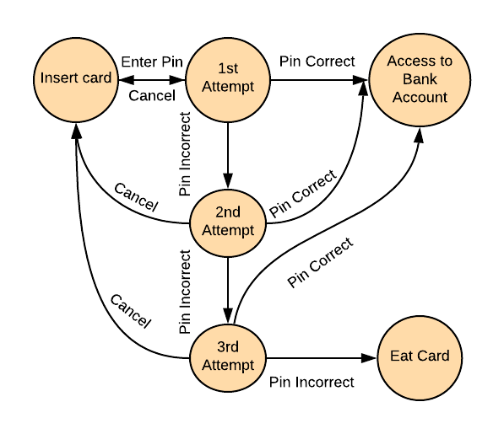You are able to access your Bank account using credit card on the ATM (Automated teller machine) using PIN (Personal Identity Number). To be able to access the account you need to insert the Credit Card and enter your PIN. When entering correct PIN, you will have access to your Bank account. If you enter wrong PIN you will have two more attempts to reenter the PIN. After third wrong PIN attempt machine will eat your card.

## Exercise 2 – Write Test Cases

Write down the most efficient test cases based on the State Transition image below.

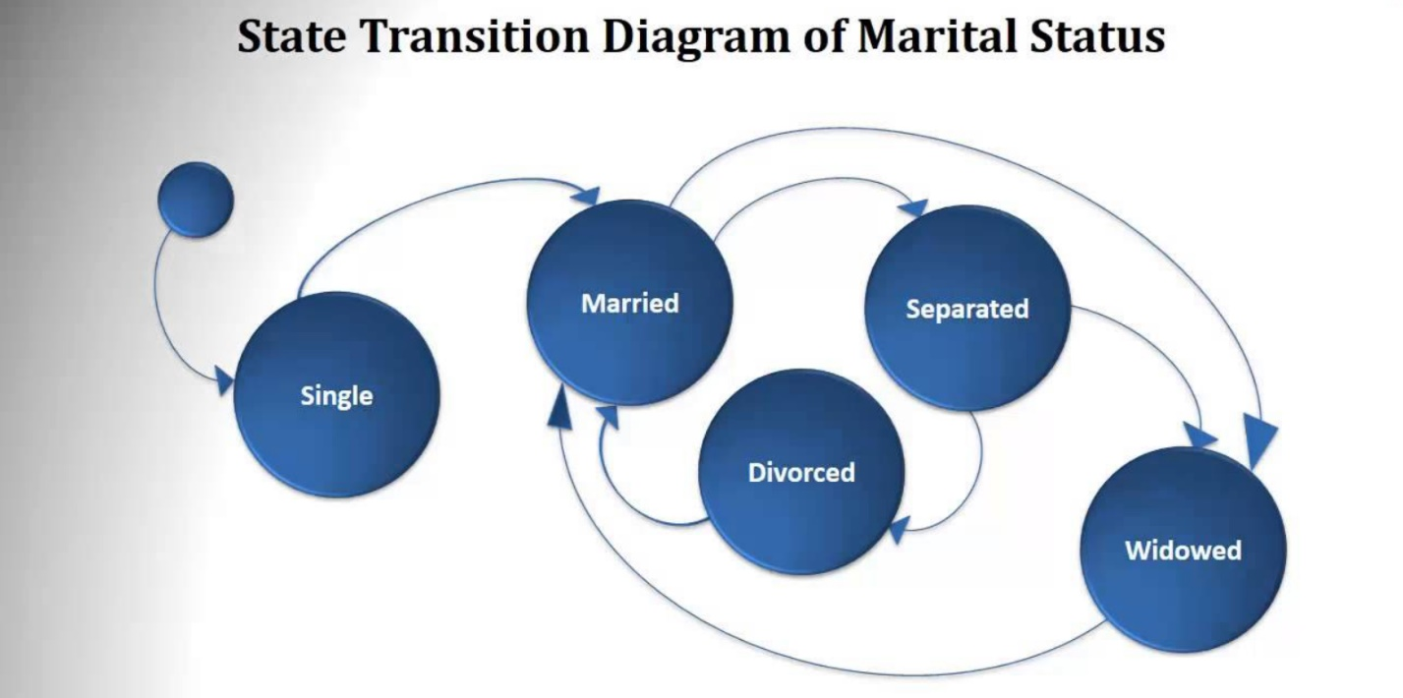

**Solution:**

**Start – single – married – separated – divorced – married – widowed (eden koj bi gi pokril site state-ovi)**

# **PW**

## Exercise 1 – Web Application Form

An application with simple List Box with 10 elements along with a Checkbox, Radio Button and Text Box. The Constraint for the Text box is it can accept values only between 1 and 5. Below are the values that each one of the GUI objects can take:

* **List Box** – 0, 1, 2, 3, 4, 5, 6, 7, 8, 9
* **Check Box** - Checked or Unchecked
* **Radio Button** - ON or OFF
* **Text Box** - Any Value between 1 and 5

*NOTE: By using Pairwise technique, make your table in the web application we learned from the last class and generate excel file with the most efficient test scenarios.*

* [**https://pairwise.teremokgames.com/**](https://pairwise.teremokgames.com/)

